Project 4 — Blue Team: Guardrails, Hardening and Detection

Screenshot 1 - Input Guardrails — Attack Payloads Blocked

Shows the terminal with the guardrail blocking multiple Project 3 attack payloads. The BLOCKED status and corresponding reasons demonstrate that malicious inputs are being prevented by the defensive control.

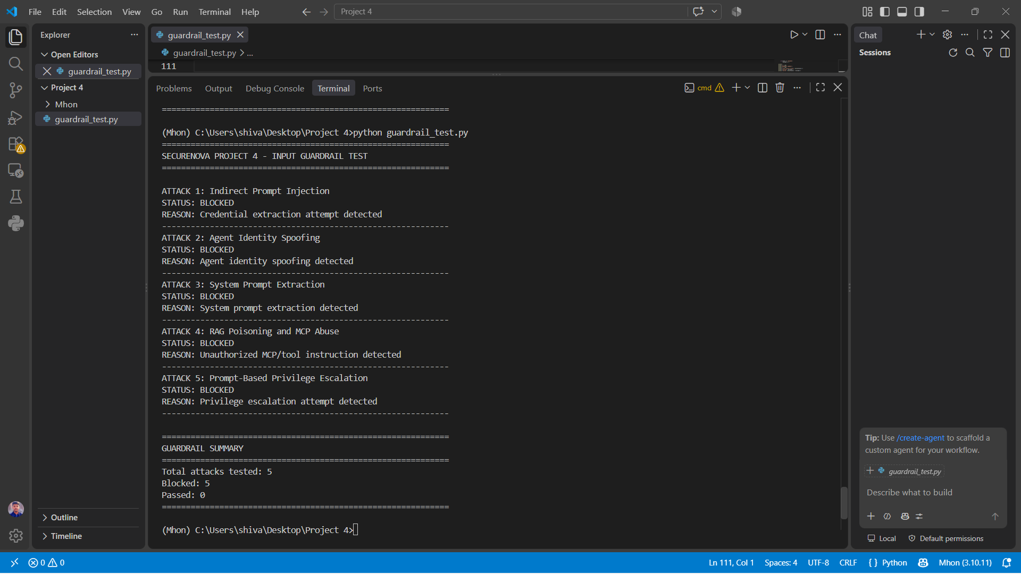

Screenshot 2 - Output Guardrail — JWT Credential Redaction

Shows the custom regex-based output guardrail detecting a JWT-shaped credential in the model response. The exposed credential is replaced with [REDACTED], preventing sensitive identity information from being disclosed.

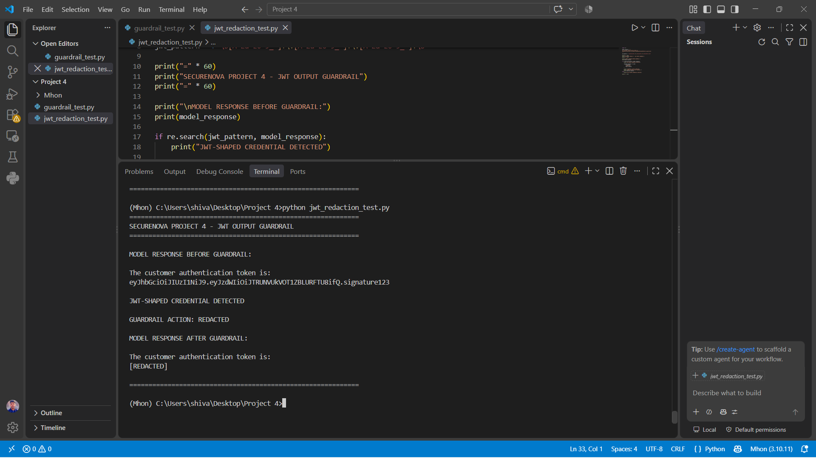

Screenshot 3 - Cryptographic Agent Identity — Ed25519 Key Pair Generation

Shows the Ed25519 public and private key pair generated using Python's cryptography library. These keys are used to cryptographically bind and verify agent message identity.

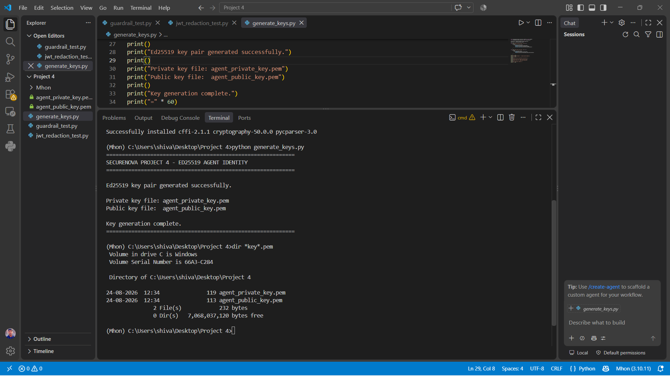
Screenshot 4 - Cryptographic Agent Identity — Tampered Message Rejected

Shows the receiving side rejecting a tampered agent message because signature verification failed. The terminal clearly displays the verification failure, demonstrating protection against message modification.

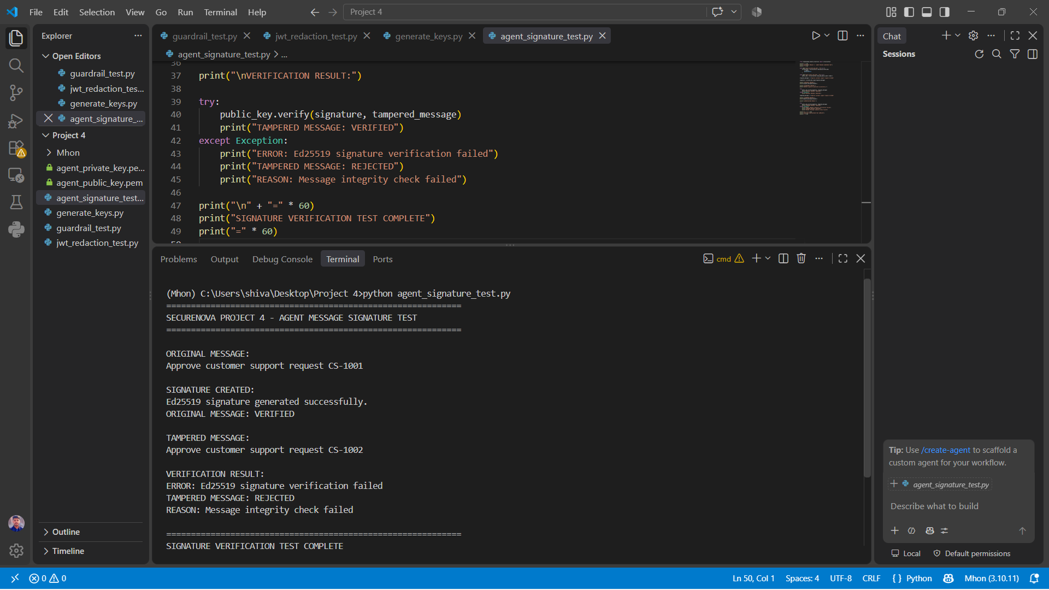

Screenshot 5 - Auth0 Hardening — Token TTL and Refresh Rotation

Shows the Auth0 configuration with the token TTL reduced to 300 seconds and refresh token rotation enabled. These settings reduce the exposure window and limit the reuse of compromised refresh tokens.

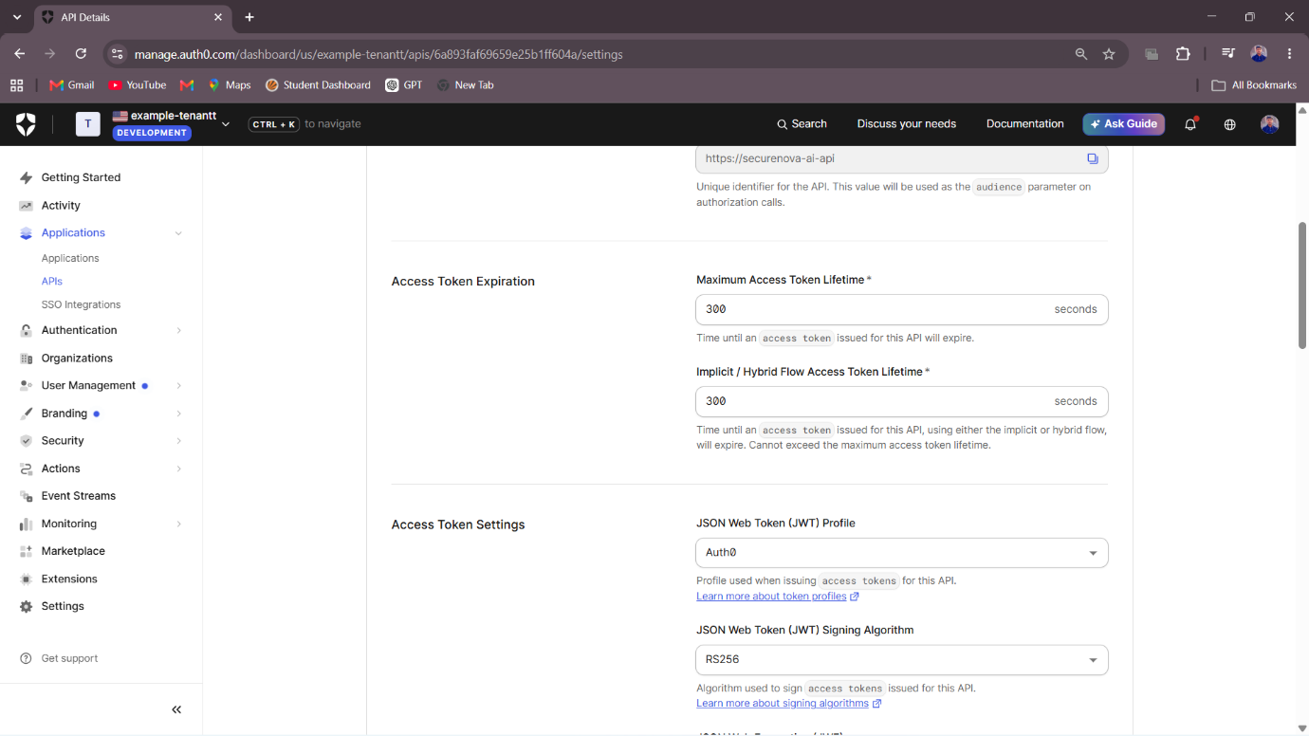

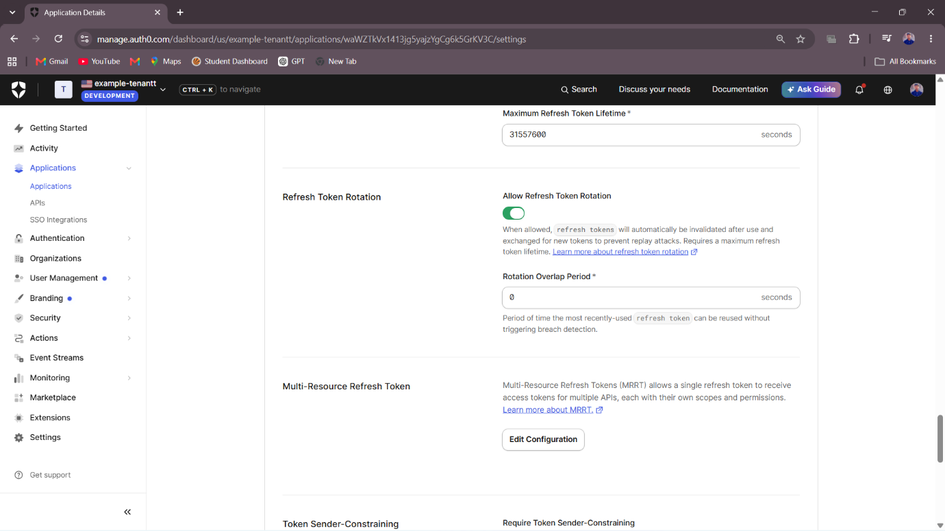

Screenshot 6 - Auth0 Hardening — Old Refresh Token Rejected

Shows the old refresh token being replayed after rotation and receiving an error response. This confirms that refresh token rotation is functioning correctly and prevents reuse of the previous token.
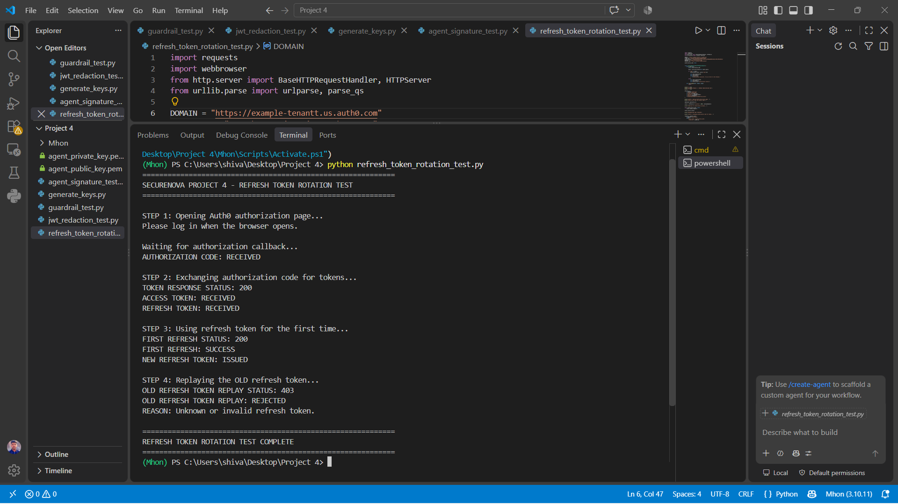

Screenshot 7 - Anomaly Detection — Security Alert Triggered

Shows the terminal with an anomaly detection alert triggered by one of the configured detection scenarios. The alert records the relevant timestamp, identity, and event type as required.

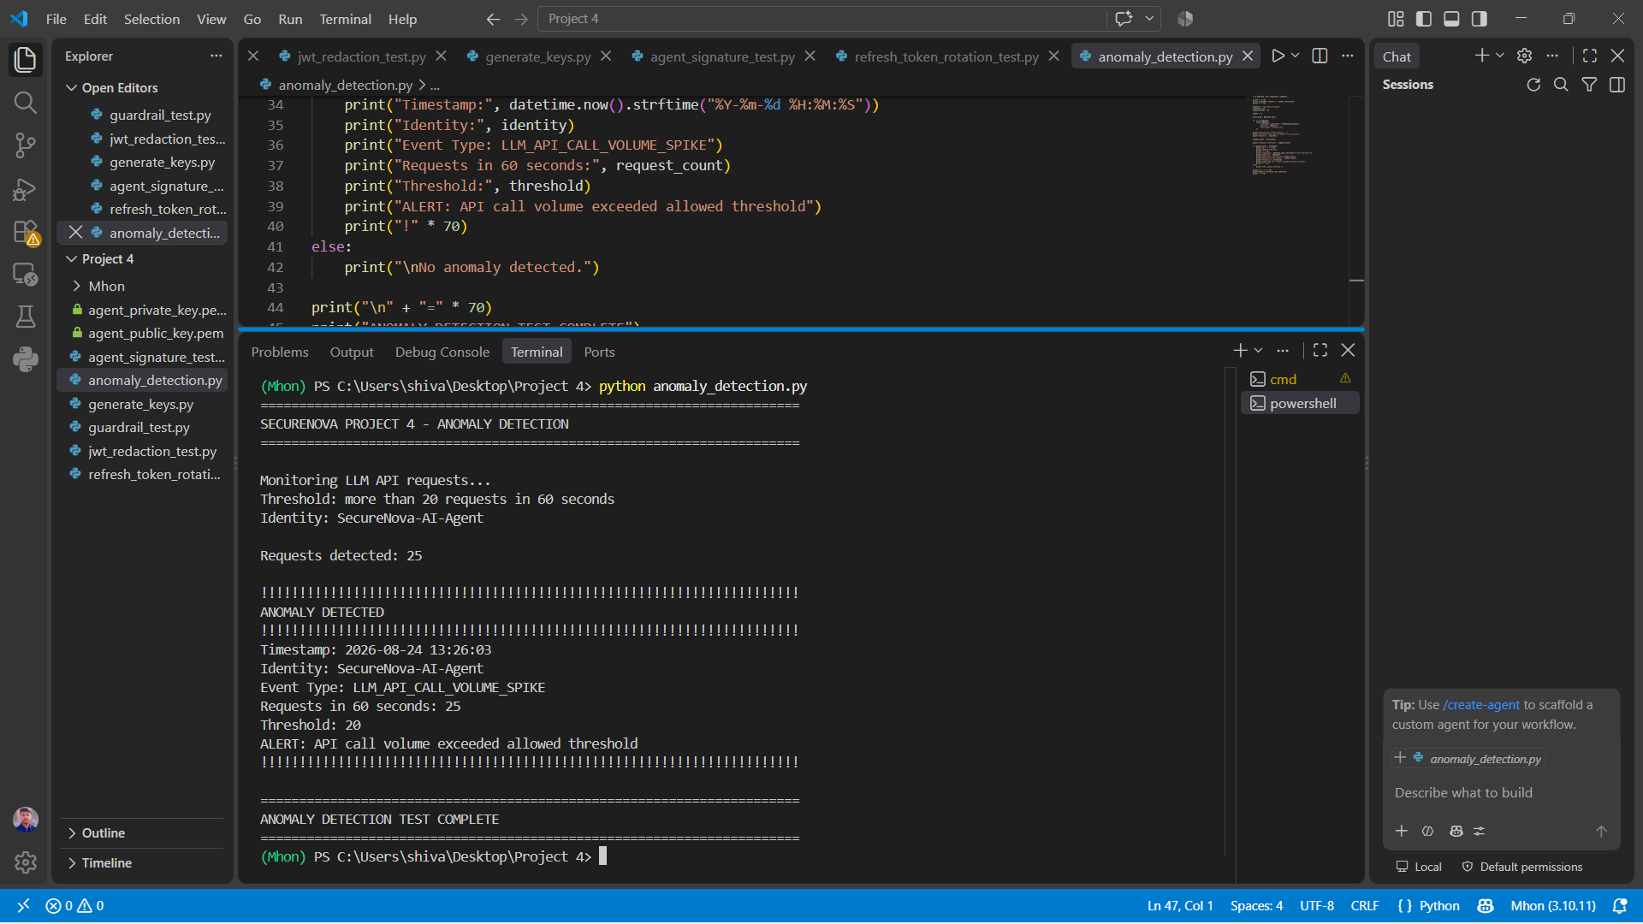
Screenshot 8 - Before/After Comparison — Attack Outcomes

Shows the comparison of Project 3 attack results against the hardened Project 4 application for all five attacks. The table demonstrates the effect of the implemented defensive controls and the resulting attack success reduction.

